**Title of work: Schedule Lab**

**Name :** Shani Patel

**Student number :**152243192

**Section Code:** NEE

**Date submitted:** 21/07/2021

**Professor's name:** Tevin Apenteng

1. Create a class diagram to support the above case study and Systems Use Case Specifications

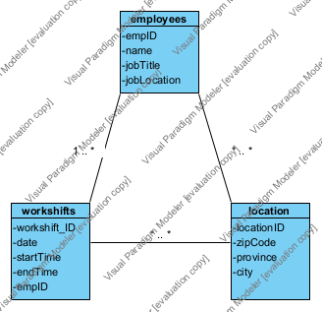

1. Create an object level sequence diagram, detailing the Create Employee Workshifts use case specification

